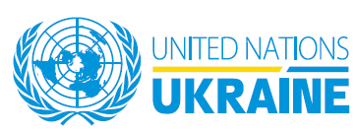
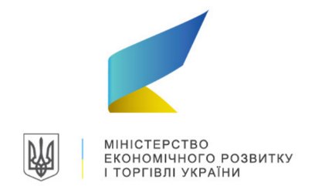
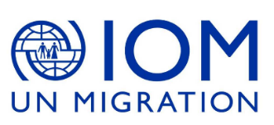
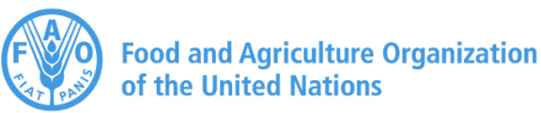

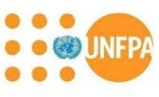
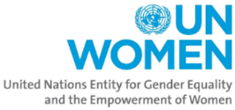
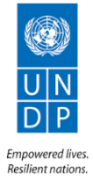
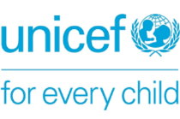

Press release
21 May 2018

SDG Media Awards 2018
«Sustainable Development Goals: Leaving no one behind»

The United Nations system in Ukraine, including FAO, IOM, UNDP, UNFPA, UNICEF and UN Women together with the Ministry of Economic Development and Trade invite journalists working in national and regional media in Ukraine, as well as students of journalism, bloggers and freelancers, to take part in a journalistic contest which will gather and award best material on achievement of the Sustainable Development Goals in Ukraine.

Participation in the competition is open for authors who will publish materials on the subject of the contest during the period between January 1, 2018 and December 1, 2018.

Nine winners (One winner per each nomination) will receive certificates and 5000 UAH/or diplomas for the purchase of technical journalistic devices (at the choice of the contestant, costing up to 5,000 UAH). Their materials will be published on the UN web resources in Ukraine with the author's name.

The awarding ceremony will be held in January 2019.

Requirements:

• Materials should be prepared in Ukrainian or Russian;
• Publications should focus on Ukraine, reflect the real state of affairs and concrete examples of solving problems related to SDGs, talk about the experience and practice of transition to sustainable development;
• Preference will be given to publications that specifically reference SDGs;
• Texts submitted by journalists and media representatives should be completely original and contain no plagiarism.

The winners will be selected by an independent jury, which will include representatives of United Nations in Ukraine agencies/funds/programs, partners and experts.

List of nominations:

Responsible consumption and food security in Ukraine  (Funded by FAO)  To receive data related to the topic, consultation or comment from the expert, contact FAO in Ukraine:  +38 093 7380730  FAO-UA@fao.org | A growing global population with deteriorating natural resources and increased urbanization means more people to feed with less water, farmland and rural labour. Today, the world wastes or loses around a third of the food it produces while 815 million people go hungry. To feed the world sustainably, producers need to grow more food while reducing negative environmental impacts such as soil, water and nutrient loss, greenhouse gas emissions and degradation of ecosystems. Consumers must be encouraged to shift to nutritious and safe diets with a lower environmental footprint.  This nomination will consider materials focused on:  - Activities and projects on food losses and waste reduction, partnering with private sector, international organizations and civil society;  - The SAVE FOOD initiative in Ukraine, its perspectives and practical approach;  - Education and networking as a basis for developing a sustainable approach to responsible consumption (SDG12).
Sustainable entrepreneurship and economic growth in Ukraine  (Funded by IOM and UNFPA)  To receive data related to the topic, consultation or comment from the expert, contact IOM and UNFPA in Ukraine:  + 380 44 568-50-15, +380 44 281 32 32  iomkiev@iom.int, ukraine.office@unfpa.org | The SDGs present an opportunity for business-led solutions and technologies to be developed and implemented to address the world’s biggest sustainable development challenges. As the SDGs form the global agenda for the development of our societies, they will allow leading companies to demonstrate how their business helps to advance sustainable development, both by minimizing negative impacts and maximizing positive impacts on people and the planet.  This nomination will consider materials focused on:  -Responsible consumption and production;  -Confronting climate change;  -Business partnerships for sustainable development (e.g. Pact for Youth 2020)
SDGs and migration  (Funded by IOM)  To receive data related to the topic, consultation or comment from the expert, contact IOM in Ukraine:  + 380 44 568-50-15,  iomkiev@iom.int | The UN 2030 Agenda for Sustainable Development calls for the facilitation of orderly, safe, regular and responsible migration and mobility of people, including through the implementation of planned and well-managed migration policies. It acknowledges the development potential of migration, owing to the intellectual, cultural, human and financial capital that migrants contribute to the social and economic development of their host societies and communities, as well as countries of origin.  This nomination encourages materials dedicated to the following topics:  -Prevention of trafficking in persons and offering survivors of trafficking safe and sustainable reintegration support;  -Ethical recruitment, decent working conditions and safe migration as enablers of migrants’ contribution into the development of their countries of origin and destination;  -Migrants help cities to become more vibrant, successful centers of economy and life. Local governments encouraged to include migration and migrants in their urban development planning and implementation;  -Migrant heroes.
Partnerships for successful implementation of the Sustainable Development Goals  (Funded by UNDP)  To receive data related to the topic, consultation or comment from the expert, contact UNDP in Ukraine:  + 380 44 253 9363,  communications.ukraine@undp.org | The achievement of the goals of sustainable development requires deep socio-economic transformation in Ukraine, in which collaborations between the government and other actors in the society play a key role. Journalistic materials in this nomination may relate to:  -Successful practices and problems in the implementation of the goals of sustainable development at the national / local level;  -Dialogue of authorities and society on ways to implement the goals of sustainable development in Ukraine;  -Partnership of the Government and other stakeholders on the implementation of the Sustainable Development Goals in Ukraine;  -Best practices on implementation of SDGs in Ukraine and abroad.
Innovation for Change (funded by UNDP)  To receive data related to the topic, consultation or comment from the expert, contact UNDP in Ukraine:  + 380 44 253 9363,  communications.ukraine@undp.org | Achieving the 2030 Agenda for Sustainable Development requires new innovation approaches that are socially inclusive and environmentally benign. In this category a media publication might refer to:  - The contribution of innovation to economic growth and well-being;  - Ecological innovations;  - Innovatio2цувамї\ns in service provision;  - Innovations for regional development;  - Inclusive innovation;  - Innovative approaches for the implementation of the Sustainable Development Goals.
Dialogue for peace and tolerance (funded by UNDP)  To receive data related to the topic, consultation or comment from the expert, contact UNDP in Ukraine:  + 380 44 253 9363,  communications.ukraine@undp.org | Reducing social tensions is essential for restoring peace and recovery of eastern Ukraine, building a respectful and open atmosphere in the host communities and society as a whole. In this category a media publication might refer to:  - Civic initiatives aimed at boosting dialogue and mutual respect in Ukrainian society.  - Successful co-operation and interactions between IDPs and host communities.  - Sport or cultural events aimed at promoting the principles of tolerance and respect for human rights.  - Building an inclusive Ukraine.
Civil Society for the Sustainable Development Goals (funded by UNDP)  To receive data related to the topic, consultation or comment from the expert, contact UNDP in Ukraine:  + 380 44 253 9363,  communications.ukraine@undp.org | Ukraine's vibrant civil society is a partner of the state authorities in making progress towards the Sustainable Development Goals, reform implementation, and the creation of positive changes in local communities.  In this category a media publication might refer to:  - Best practices of all-Ukrainian or regional civil society organizations and initiative groups regarding the implementation of the SDGs;  - Highlighting the role of individual civil activists in the implementation of SDGs in Ukraine;  - The experience of partnership between CSOs/NGOs (including youth NGOs) and local/central authorities regarding the implementation of the Sustainable Development Goals.
SDGs and Youth in Ukraine  (Funded by the UNFPA)  To receive data related to the topic, consultation or comment from the expert, contact UNFPA in Ukraine:  +380 44 281 32 32,  ukraine.office@unfpa.org | Young people play a crucial role in achieving the Sustainable Development Goals (SDGs) by 2030. Over a third of the 169 SDG targets highlight the role of young people and the importance of their empowerment, participation, and well-being. We welcome journalists’ materials that reflect topics on Youth and SDGs, in particular:  -Important role of youth activism and innovations in achieving SDGs;  -Leadership and empowerment of young people to enable them driving change in their communities;  - Ensuring healthy lifestyle among youth (anti-tobacco and alcohol issues, preventing of HIV and other sexually transmitted infection);  -Youth Well-Being Index;  -STEM for girls;  - Girls and sport (combating stereotypes that football isn’t for girls and ensuring healthy and active lifestyle).
Progress for every child in the SDGs era (Funded by the UNICEF)  To receive data related to the topic, consultation or comment from the expert, contact UNICEF in Ukraine:  +380 44 254-24-50  kiev@unicef.org | The achievement of the SDGs requires a structural transformation of the society based on the ‘leaving no one behind’ approach. The SDGs represent the highest aspirations for a better world and reflect the greatest responsibility of a global community. We have to provide children and young people today with the services, skills and opportunities they need tomorrow to build better futures for themselves, their families, and their societies. This understanding – that a sustainable future depends on how we meet the needs of children and young people today – is at the core of the SDGs.  This nomination will consider materials focused on:  - Translating Ukraine’s current and long-term development strategies into prospects for children;  - Data and SDGs: Innovative approaches related to data for SDGs;  - Best practices on child rights monitoring for implementation of the SDGs (in Ukraine and abroad);  - How can child and youth friendly municipality initiative accelerate the SDG agenda in Ukraine.
Equality between women and men is the key to peace and development of Ukraine  (Funded by the UN Women)  To receive data related to the topic, consultation or comment from the expert, contact UN Women in Ukraine:  + 380 44 384 12 81,  unwomen.ukraine@unwomen.org | Peace and development in Ukraine cannot be fully realized if half of the country's population is still struggling to secure its own rights and opportunities. Women and girls should be equal with boys and men in terms of employment, leadership and decision-making at all levels. Journalists in this category should discuss such topics as:  -Overcoming gender-based discrimination;  -Opposition to gender-based violence;  -Promoting equality between men and women in all aspects of life at the national, regional and local levels (economy, politics, private business, etc.).

